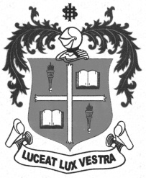
LOYOLA COLLEGE (AUTONOMOUS), CHENNAI – 600 034
M.A. DEGREE EXAMINATION - APPLIED HISTORY
SECOND SEMESTER – APRIL 2012

HT 2810 - EUROPE IN TRANSITION AFTER THE WORLD WAR - II

Date : 21-04-2012 Dept. No. Max. : 100 Marks

Time : 9:00 - 12:00

PARI-A

Answer any four of the following in a page each: (4x5=20)

- Truman Doctrine
- North Atlantic Treaty Organization
- Berlin Blockade
- Labour Party in Britain
- Socialism
- Commonwealth Nations

PART-B

Answer any two of the following in two pages each: (2x10=20)

- Write a short note on European Recovery Program.
- Explain the role of France in the Second World War.
- Give a brief account on Communism and its impact on European countries.
- Examine the role of Glasnost and Perestroika for the disintegration of erstwhile USSR.
PART-C

Answer any three of the following in four pages each: (3x20=60)

- Describe the impact of the Second World War on Europe.
- Narrate the various causes for the Cold War.
- Estimate the role of Conservative Party in making the British Government.
- Critically examine the emergence of USSR as Super Power with its ideology of Communism.
- Discuss the achievements and challenges of European Union.

********

